**Assignment Steps:**

### **Objective:**

The objective of this assignment is to assess your ability to automate the navigation and interaction with web elements using a web automation tool of your choice (e.g., Selenium, Cypress). Need to complete all the Test Cases given below

### **Task Details:**

1. **Navigate to the FitPeo Homepage:**
   * Open the web browser and navigate to [FitPeo Homepage](https://www.fitpeo.com/).
2. **Navigate to the Revenue Calculator Page:**
   * From the homepage, navigate to the [Revenue Calculator Page](https://fitpeo.com/revenue-calculator).
3. **Scroll Down to the Slider section:**
   * Scroll down the page until the revenue calculator slider is visible.
4. **Adjust the Slider:**
   * Adjust the slider to set its value to 820. we’ve highlighted the slider in red color, Once the slider is moved the bottom text field value should be updated to 820
   * 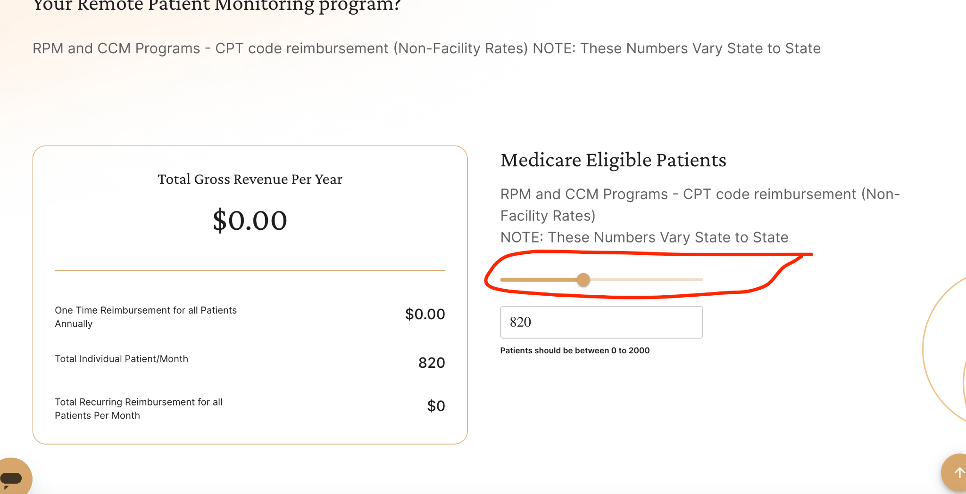
5. **Update the Text Field:**
   * Click on the text field associated with the slider.
   * Enter the value 560 in the text field. Now the slider also should change accordingly
6. **Validate Slider Value:**
   * Ensure that when the value 560 is entered in the text field, the slider's position is updated to reflect the value 560.
7. **Select CPT Codes:**

Scroll down further and select the checkboxes for CPT-99091, CPT-99453, CPT-99454, and CPT-99474.

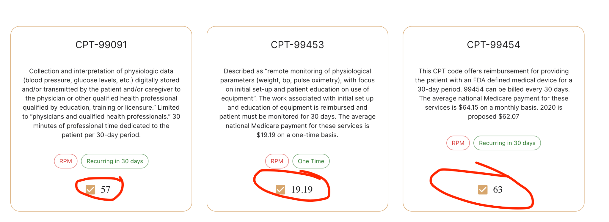

1. **Validate Total Recurring Reimbursement:**
2. Verify that the header displaying Total Recurring Reimbursement for all Patients Per Month: shows the value $110700.



### 

### 

### 

### 

### **Requirements:**

* Use any web automation tool (e.g., Selenium WebDriver) and any programming language you are comfortable with (e.g., Java, Python, JavaScript).
* The script should be well-documented and easy to understand.
* Handle possible exceptions and ensure the script runs smoothly.

### **Submission:**

* Provide the source code of your automation script.
* Include a brief document explaining how to set up and run your script.
* Ensure your script is runnable in a standard development environment with minimal setup.

### **Additional Information:**

* Make sure to test your script thoroughly before submission.
* Pay attention to the dynamic nature of web elements and ensure your script can handle such scenarios.
* Ensure the script is maintainable and adheres to best coding practices.

**Submission**:

Once you have completed the assignment, submit the following form

Form Link: <https://forms.gle/C3yhZhA34YKuZeXa6>